**ATAR Modern History**

**Year 12– 2018**

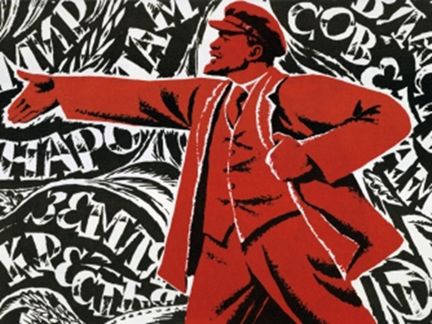 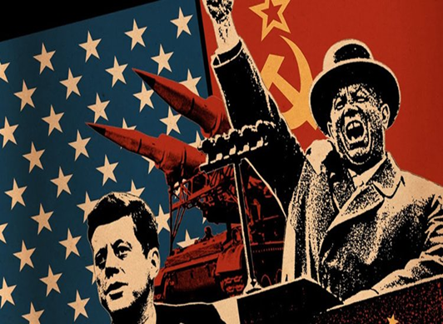

**Source Analysis Guide**

**Introduction**

Historians use historical evidence to construct a picture of the past. They find this in sources. A source is *anything* which survives from the past or tells us about the past.

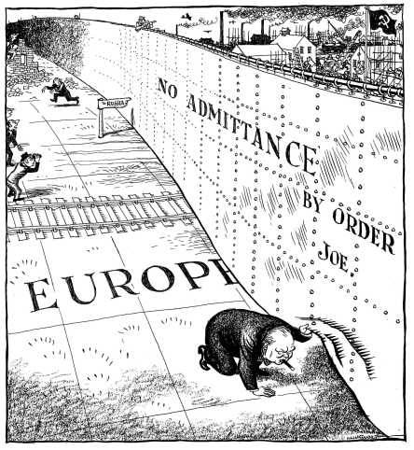

**Thinking Skills for Source Analysis**

Answering source analysis questions requires a comprehension of what you are reading or viewing, background knowledge of the time period the source is produced in or, is referring to (context), and an evaluation of its reliability and accuracy.

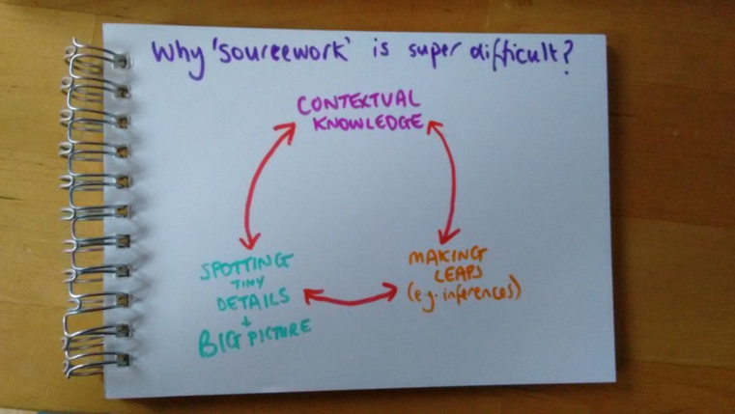

Developing these thinking skills is key to success in source analysis. By practising, working through class exercises and reviewing the marking key for each assessment you can develop the necessary analytical skills.

Einstein once said that ‘*Insanity is doing the same thing over and over again and expecting different results.’*  For improvement you must be willing to receive feedback from your teacher and act upon it !!!!

**Common Mistakes in Source Work**

There are mistakes and assumptions that students make when working with sources. Here are some below to avoid;

* Saying that primary sources are more reliable than secondary sources because they were made at the time. This may not be the case as some primary sources are used for propaganda purposes or the person producing it may be influenced by factors we know nothing about. Secondary sources can be helpful in analysis and providing a bigger picture of an event.
* Saying that there is no bias in a government source or a school text book. Every text type is the product of some kind of bias (one-sidedness) because they contain opinions as well as facts. Students need to understand the purpose of the construction of a source to evaluate the level of bias present. An extremely biased source can tell us a lot !!
* Not using examples from the source to support analysis. Once you make an inference about what a source is telling you then you must show your marker your thinking by using examples from the source.

**Key Concepts in Source Work**

In the table below look up and complete the following definitions.

|  |  |
| --- | --- |
| Key Concept | Definition |
| Continuity and Change |  |
| Perspectives |  |
| Contestability |  |
| Evidence |  |
| Empathy |  |
| Significance |  |
| Cause and Effect |  |
| Context |  |
| Historiography |  |
| Bias |  |
| Accuracy |  |
| Reliability |  |

**Types of Sources**

The most common type of sources you will see in a document set include; photographs, political cartoons, propaganda posters, government documents, speeches, observations by visitors and analysis by historians. They will all have value in what they can tell us or not tell us and for every one of them you need to ask these general questions in the graphic below.



**Tips for Types of Sources- What to look for.**

**Political Cartoons**

* Political cartoons offer insight into the public mood in the time, they can show us attitudes and values of the general public.
* The main purpose of a cartoon is to provide a social commentary which can take the form of ridicule or satire. They like to mock something, to show how false or unfair it is.
* Symbols are used in the drawings that might be of the time and hard for our modern eyes- so you must have a good knowledge of the time period. Simple symbols can denote big ideas eg a dollar sign could be a symbol for the whole economy.
* Images can be distorted to suit the cartoonist and features are exaggerated.

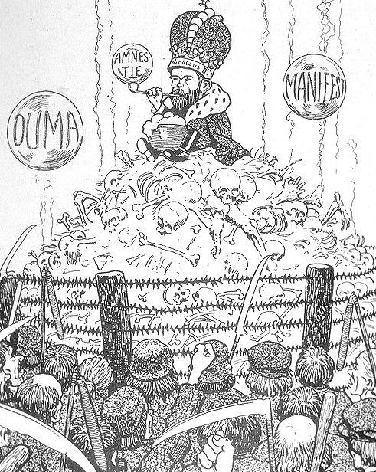 *A French cartoon from 1905, criticising Nicholas’ leadership.*

* Cartoonists use stereotypes to portray people and institutions.
* The title is often an argument not a slogan. It can invite you to argue back.
* They aim to be thought provoking.

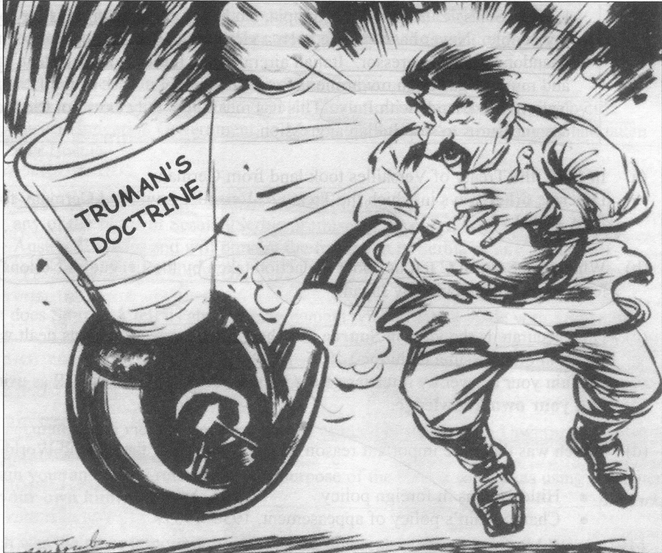 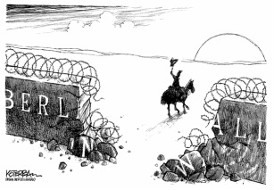

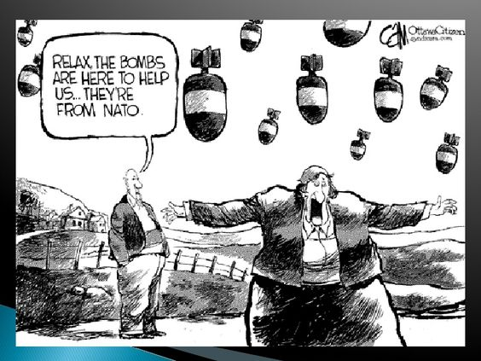

**Photographs and Propaganda Posters**

* Photographs are useful sources and you will find at least one in most document booklets, however they can be distorted and the purpose of the photographer must be evaluated.

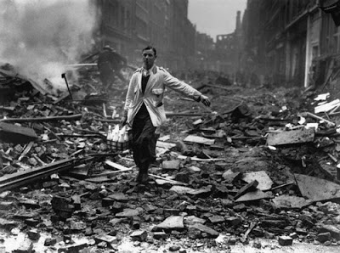

This picture was taken in London in 1940 at the height of German bombing (the Blitz). It was taken at the time, however it is a fake. The ‘milkman’ was the photographer’s assistant but the photo worked to keep Londoners’ spirits high during this difficult time.

* You need to see what is in the photograph but also consider what you know about the circumstances in which it was taken.
* The acronym COMA is useful for visual sources.
* C is Context- what can you see? signs? people? Expressions?
* O is origin- where did it come from? Who created it? (you will have some information in the document set that will help with this READ IT carefully). What was happening at the time? Key dates, people and events.
* M is motive- why was the picture taken? Was it created to celebrate, to commemorate, to persuade, to ridicule or mock, to satirise, to incite anger or outrage, or to evoke some other emotional response?
* A is analysis-  The first step is to consider its factual and historical accuracy. Does the source present a fair depiction of people, events or conditions? Or does it mislead by presenting false or exaggerated information? Does it offer an overly optimistic or negative view of particular people or events? Does it use style and tone – such as satire, caricature and mockery – in a way that is fair to its subjects? Do you think the source represents the views of a majority of people – or the views and attitudes of a smaller group? Does it mislead or propagandise by omitting certain information? Does it glorify a particular leader while ignoring their faults or failures?

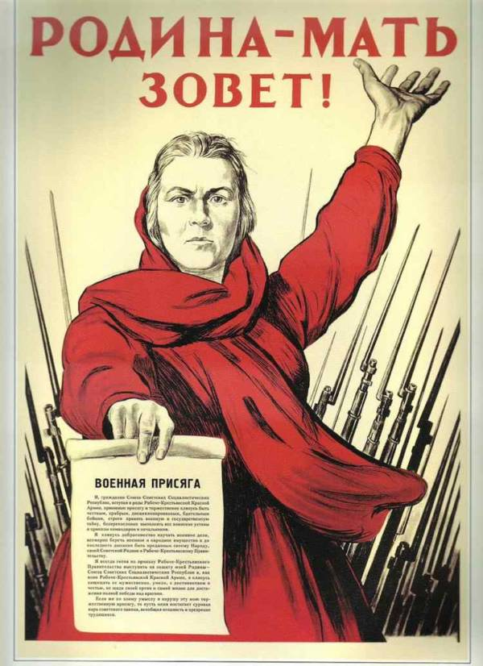Propaganda Poster Russia WW 2

**Source Questions and How to Answer them.**

In your assessments and in the WACE exam there are 5 questions for Unit 3 and 5 questions for Unit 4. Using the marking key can help you understand what is needed in each answer and should be used to check that you have given answers that can be awarded marks. Your document set will always contain 4 sources – both written and visual. The questions can be put into any order and SCASA can change the marks allocation slightly for the questions to fit. They are always out of 25 marks.

All four sources should relate to **One** of the following **six historical forces**:

1. **Economic Forces-**eg changes in economic policy by the government eg NEP, Warsaw Pact
2. **External forces/international relations**- world wars, expansion of territory, treaties
3. **Ideas/ideologies-**Capitalism, imperialism, fascism, nationalism, Communism, Socialism, Autocracy etc
4. **Leadership-**eg the role and significance of key leaders such as Lenin, Trotsky, Stalin, Churchill, Krushchev etc
5. **Political Forces-**government policies, changes in government
6. **Social/Cultural forces-**eg social change in the 1917 Revolutions, the cultural changes in Soviet Russia etc

**Time Allocation**

It is vital to break down the times for each question so you can finish them in time. Use the table below as a guide.

|  |  |  |
| --- | --- | --- |
| **Question** | **Marks**  **Allocation** | **Time**  **Allocation** |
| (a) Explain the historical context of **Source 1**. Include the relevant events,  people and ideas depicted or represented in the source. | (4 marks) | 7.0 mins |
| (b) Compare and contrast the purpose of **Source 1** and **2** | (5 marks) | 9.0 mins |
| (c) Explain the message of **Source 3**. | (3 marks) | 5.5 mins |
| (d) Identify how and discuss why **Sources 3** and **4** are **contestable.** | (6marks) | 11.0 mins |
| (e) Using your knowledge of the whole period of study, evaluate the importance  of the themes, ideas and/or events represented in the **four** sources | (7 marks | 12.5 mins |
|  | 25 marks | 45.0 mins |

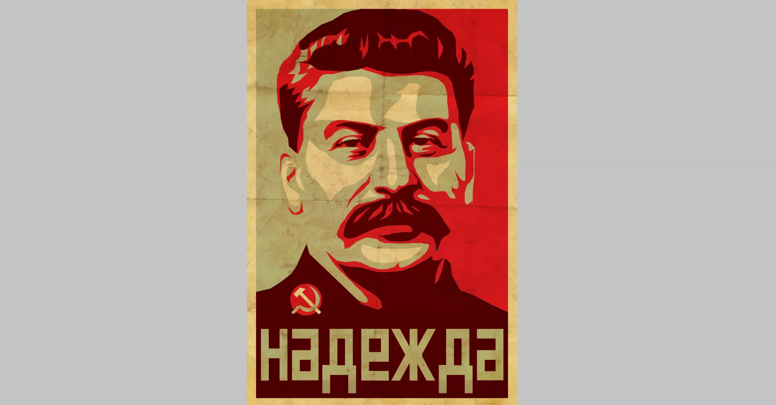

**Source Questions**

1 (a) Compare and contrast the messages in Source 1 and Source 2.

|  |  |
| --- | --- |
| **Description** | **Marks** |
| Reference to the messages in Source 1 and Source 2 | 1–2 |
| Points of comparison of the messages in Source 1 and Source 2 | 1 |
| Points of contrast of the messages in Source 1 and Source 2 | 1 |
| **Total** | **/4** |
| **Note:** Evidence should be identified from the sources to support messages. | |

The above marking key can now be used as a ‘formula’ to construct your answer. The sentence starters are in coloured italics.

Identify the message….

*The message (what does the source tell us) in source 1 is…………………………………………………………………………………………..*

*Example from the source (that provides evidence for the message)…………………………………………………………………………………..*

*The message in source 2 is……………………………………………………..*

*Example from the source……………………………………………………….*

*The messages are comparable (similar) in that they……………………………………………………………………………………………*

*Example from the Sources…………………………………………………………*

*The messages in the sources vary in that…………………………………..*

*Example from the sources………………………………………………………….*

Make sure you don’t copy out large parts of the source, this just wastes time, as is comparing and contrasting the construction or type of source- remember to stick to the message.

1(b) Evaluate the usefulness, in terms of strengths and weaknesses, of **Sources 1** and **2** as representations of…. (this could be an idea, leadership, social attitudes, policies, economics).

|  |  |
| --- | --- |
| **Description** | **Marks** |
| Provides examples of a strength and weakness of Source 1 as a representation of ….. | 1–2 |
| Provides examples of a strength and weakness of Source 2 as a representation of … | 1–2 |
| Evaluates the usefulness of the sources | 1 |
| **Total** | **/5** |
| **Note:** The response should include, where appropriate,both the strengths and weaknesses of the sources provided, in terms of how they are representative of…. | |

When assessing the relative strengths and weaknesses of the sources you could consider the following;

**Accuracy-** is the information in the source factually correct?

**Bias-**does the source provide a balanced/fair representation of the person, event, group or idea depicted.

**Omissions-**is relevant or important information omitted from the source

**Distortions-**have the facts in the source been deliberately manipulated or distorted

**Type of Source-**is the source a; propaganda poster, political cartoon, a speech/statement by a leader, an official government report, a personal account from a letter, diary etc or a historians’ argument or analysis.

*Source One is useful (strength) as a representation of….(give examples from the source in your explanation).*

*Source One is limited (weakness) as a representation of………….. (give examples from the source in your explanation).*

*Source Two is useful (strength) as a representation of….(give examples from the source in your explanation).*

*Source Two is limited (weakness) as a representation of………….. (give examples from the source in your explanation).*

*In an overall evaluation it can be seen that……. (make a definitive statement here of both of the sources in terms of their effectiveness).*

Remember a source will not be totally useless- even the most biased source reveals what an author thought at that time. This question deals with the **quality** and **quantity** of information you are getting from the source.

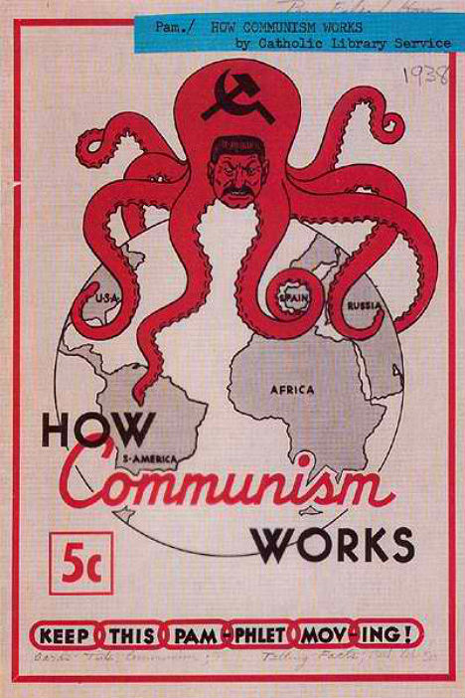

1(c) Explain the historical context of **Source 3**.

|  |  |
| --- | --- |
| **Description** | **Marks** |
| Identifies the focus of the source | 1 |
| Outlines the causes or events that led to the focus of the source | 1 |
| Provides specific details for the focus of the source, dates/events/people/place/ideas | 1–2 |
| **Total** | **/4** |
| **Note:** This question is concerned with the historical context in which the source is located. The answer must concentrate on what is in the source and explain the relevance/significance. | |

This question **does not** require you to analyse the source itself, instead it will prompt you to consider the context- the events, key people, dates, place and ideas that surround the source (it may not even show these things but will have been produced in that time).Relate the events, people or ideas referred to in the Sources to the broader context of the period of study.

Do this by asking yourself the following questions

For Events:When did it happen? What happened? Why did it happen?

For people: Who were they? What did they do? Why did they do it?

For Ideas: Who originated the idea? What did the idea involve? Why was the idea adopted/implemented? How was the idea implemented?

*The focus of Source 3 is…………………………………………………………………*

*The events that led up to this were…………………………………………………………………………………………………*

*Provide specific dates, events, people, time, place and ideas in the focus of the source.*

*No examples from the source are needed here !!*

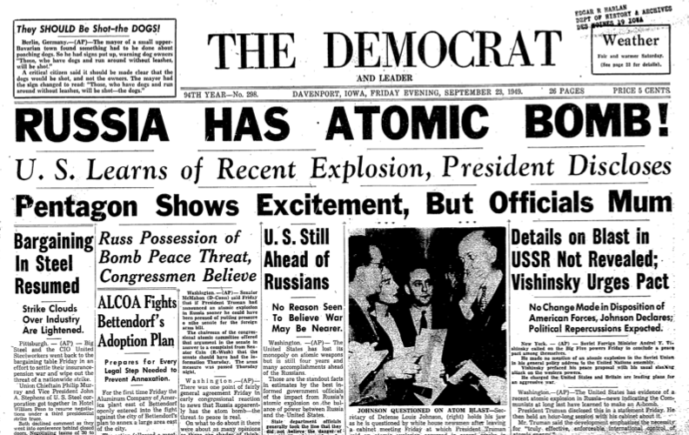

1.(d) Identify and account for the authors’ perspectives in **Sources 3** and **4** regarding the specific changes described in the documents**.**

|  |  |
| --- | --- |
| **Description** | **Marks** |
| Articulates the perspective of Source 3 | 1 |
| Articulates the perspective of Source 4 | 1 |
| Analyses of the perspectives in relation to the question asked. This may include discussion of:  • motives  • bias  • time  • place  • purpose | 1–4 |
| **Total** | **/6** |
| **Note:** The response should:   * analyse the perspectives of the sources in terms of the theme/force * articulate the perspectives from which the sources were constructed or analyse reasons for the perspective (purpose/motive/place/and time) * use evidence of the perspective from the source * identify how the author shows the perspective in the source. | |

This question is looking at perspective- you need to identify the author’s perspective by; Stating the author’s attitude towards the people, events, organisations or ideas referred to in each source.

Is the author’s attitude towards these:

1. **Positive/praising OR (ii) negative/critical OR (iii) neutral**

Give one or two pieces of evidence from each Source to support your position. Then you must account for this perspective by discussing;

1. **Who created each source and why** and how these two factors have influenced the point of view of each source? **(Motive & Purpose, Bias)**
2. **When and where each source was published** and how these factors may have affected the point of view of each source. (**time, place)**

*The author’s perspective in Source 3 is..(use evidence from the source to illustrate your point).*

*The author’s perspective in Source 4 is…(use evidence from the source to illustrate your point).*

*The perspective of the author in Source 3 can be accounted for in examining (motive, time, place, bias, purpose)….(use evidence from the source in your discussion).*

*The perspective of the author in Source 4 can be accounted for by (motive, time, place, bias, purpose)…(use evidence from the source in your discussion).*

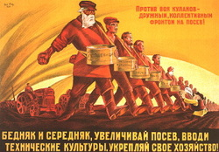

1 (e) Evaluate the extent to which the **four** sources give an accurate insight into the significance of (economic change, political leadership, ideology etc)..in your period of study.

|  |  |
| --- | --- |
| **Description** | **Marks** |
| Articulates the different aspects of changethat are shown. | 2 |
| Identifies aspects of change that have been omitted. | 1 |
| Evaluates the extent to which the sources reflect the significance of the changes depicted in the sources in terms of …… | 1–3 |
| **Total** | **/6** |
| **Note:** The response should:   * focus on what the sources say about change within the context studied, and why it may have been significant to highlight this * include the implication/impact of these changes * include the student’s own knowledge of the period of study to support their point of view. | |

When assessing the accuracy of a source consider the following:

Is the information in the source **factually correct ?**

Does the source provide a **balanced/fair representation** of the person, event, group, or idea depicted?

Is **relevant or important information omitted** from the source?

Does the source **contain distortions** of the facts or **acknowledge only one point of view?**

Significance of the people, organisations, events and ideas depicted in the sources.

Discuss how important the events/ideas/people referred to in the Sources were in shaping and determining the history of the period you are studying.

In the case of:

An **event,** focus on the **results or consequences,** and **explain why** these are important.

A **person**, focus on the **individual’s deeds**- both good and bad, and **explain the significance** of their actions.

An **idea,** focus on the **economic, political and social changes** that the idea brought about in American/German society during the period of study.

*All four sources show …. (describe the different aspects of change shown across the 4 sources-DO NOT LIST your sources here).*

*However, they omit ….(state the general omission, something important that they all miss NOT ONE OMISSION FOR EACH SOURCE).*

*The extent to which the sources are accurate in giving insight into (the change in the time period) are…. (make a judgement here, are they accurate in giving us some idea or insight into the ideas or changes of the period). Give evidence from the sources to support your evaluation and use any extra information you know to make that judgement on accuracy.*

**Strategies for Interpreting Different Types of Documents:**

**(a) General Points:**

* Highlight the “instruction words” in the Source Analysis questions.

* These words tell you what you are required to do in order to answer each

question.

* Examples of instruction words include:

***compare, contrast, explain, discuss, evaluate* , etc.**

**\*** For each Source **highlight the year of publication –** this will help you to

identify the people and events to which the source is referring, thereby making it possible to put the Source into its historical context.

* The **author and** / **or publisher** of the Source should also be highlighted - this will enable you to identify the purpose and bias of the Source.

**(b) Text:**

* Highlight the words and phrases that show the key points or ideas

being presented by the author.

* Annotate the Source by jotting down these key ideas in your own words.

* Make a note of any countries, individuals, groups, events or organisations

referred to in the Source.

* Try to identify the tone of the written expression used by the author – is it

praising, critical, sarcastic, ironic, etc.

* The tone of the Source is important because it indicates the author’s

bias or point of view.

.**(c) Cartoons:**

* Highlight any captions, labels or speech bubbles that appear on the cartoon.

* Identify the countries, individuals , groups, events or organisations referred to in the cartoon and indicate the symbols and stereo-types that have been used by the cartoonist to depict them.

* Determine whether the cartoonist has portrayed the people and events in a positive or a negative way.

* Assess the accuracy and fairness of the how the cartoonist has depicted the people and events referred to in the cartoon.

* Note that dot points three and four also apply to the analysis of paintings and photographs.

**(d) Statistics:**

* Tables and graphs use numbers to show the rate and extent of economic,

political and social change over a period of time.

* When analysing statistics try to identify and account for:

- upward or downward trends

- peaks and troughs (ie maximum & minimum values )

- unexpected or extreme values

* Identify the author/publisher of the statistics as this will help you determine both the purpose and bias of the data.

* Knowing who produced the data, and what point of view it supports, is

essential in order to assess its reliability - as Mark Twain once said

“there are lies, damn lies and statistics!”.

**Interpreting the Historical Evidence contained in the Sources**

**Purpose / Motive:**

**\*** The purpose / motive of the Sources that you analyse will vary but could include the

following:

- **Propaganda** , where the Source has been created for the purpose of deliberately misleading, manipulating or deceiving the reader. Sources that also try to convince the reader of a particular point of view could also fall under the heading of propaganda.

- **Commentary or critique on contemporary people or events** – political cartoons often fall into this category.

- **A historian’s interpretation** of people and events from the past – extrac from textbooks are the most common examples that you will encounter

- **Personal Accounts /** **Memoirs** of individuals who had direct involvement with significant people and events from the past.

- **Official documents** which for example might attempt to explain or justify government policy on a particular issue.

**Place & Time:**

* For the purpose of the WACE Mock Exam, we will assume that Place & Time refers to the way in which perspectives about people, events and themes from history change over time.

* For example a historian assessing the importance of Lenin to Russian history, fifty years after his death, is going to have a different perspective about Lenin compared to a member of the Bolshevik Party who was present in Russia at the actual time of Lenin’s death.